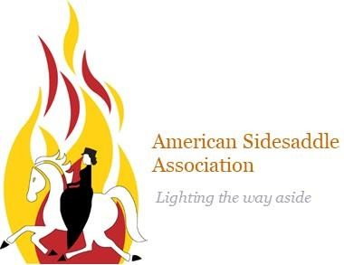
Sidesaddle
Clinic

When: Thursday, August 24th 2023
4pm to 6pm
Where: Breakaway Farm
16 US Route 2
Grand Isle, VT, 05458
Ever wanted to try sidesaddle? Now is your chance! Maggie, president of the American Sidesaddle Association, will be bringing saddles and the other supplies in order to find the perfect fit for you and your horse. This event will include lessons on the history, proper fit, and the various styles of sidesaddle.
Fees:
Riders, non ASA Members: $80 (fee includes membership to ASA)

Riders, ASA Members: $55
Auditor: $25 (Fee includes social membership to ASA)

To register contact:
Sarah Pettitt: reins@breakaway-farm.com

*Safe riding attire and footwear required.
* Boots and helmets are available on loan
*Liability waivers for the barn will be signed upon arrival.
*Negative coggins required for visiting horses ( additional $25 stall fee required)
** This event will take place rain or shine.
***Nonrefundable or transferable unless the event is canceled by event creator.

