Breakaway Farm Enterprises
Summer Riding Camp
Camper Information ( Short)
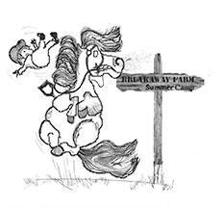
WARNING
Under Vermont Law, an equine activity sponsor is not liable for an injury to, or the death of, a participant in equine activities resulting from the inherent risks of equine activities that are obvious and
necessary, pursuant to 12 V.S.A. § 1039.
Camper Name _____________________________________
Camper Age _______________________________________
Camper Height __________________ Camper Weight ________________
Riding ability can be best described as: Beginner, Advanced Beginner, Intermediate Riding Style: Western,English
Parent One Name_________________________________________________
Parent One Emergency Phone Number: __________________________________
Parent Two Name _________________________________________________ Parent One Emergency Phone Number
Alternative Emergency Contact Name_______________________________________________ Alternative Emergency Contact Phone Number____________________________
Sessions attending (circle one or more):
Session 1 June 23rd to June 27th
Session 2 June 30th to July 4th
Session 3 July 7th to July 11th
Session 4 July 14th to July 18th

